Environment and Economics
Name:
Course Tittle:
Course number:
School affiliation:
Date:

Introduction
What is environmental economics?
Economics is defined as a science which uses theories, methods, and values to understand how goods and services are produced in the society in an efficient way. On the other hand, the environment is the natural earth place which hosts resources and life for its habitats. Environmental economics acknowledges the needs of the environment and the economic activities therein. Environmental economics is key in the evaluation and understanding of some of the most controversial issues and topics such as the recycling policy, nuclear power, traffic congestion, the issue of renewable power/energy and so forth (Dasgupta, Pattanayak, & Smith, 2018).
Economic discipline plays a major role in sustainable development. Environmental economics takes care of the environment and policies therein and how economic activities affect the environment. Other issues that are looked into in the discipline include pollution and the various ways we can reduce pollution as well as other key issues. Environmental economics involves the study of environmental science and how human beings interact with the environment. It also involves a deep understanding of the vulnerability of the environment and how it adapts to various challenges such as global economy, emissions, policies, business, and production. The key environmental economics approach is to balance environmental degradation and economic activity. The topic also gives a limelight on how the environment can be advanced economically (Singh, & Shishodia, 2017).
The central question in the research is; what is the role of economic discipline in environmental sustainability and development? A case study of the water pollution on NYC Gowanus canal has been used to demonstrate how economic activities have destroyed the environment such as rivers, seas, forests, etc. The research will seek to understand how economic activities have led to eh depletion of resources and what can be done to use them to change the environment. The need to have economic activities which enhance environmental sustainability is important.
Water pollution on NYC Gowanus canal
Surrounding this canal are three manufactured gas plants which greatly contribute to polycyclic aromatic hydrocarbon contamination. Other companies which have greatly contributed to the pollution of the Gowanus Canal include; Metropolitan Gas Light Company MGP site. The canal also exhibits characteristics of contaminations of coal and tar which has affected the quality of water in the canal.
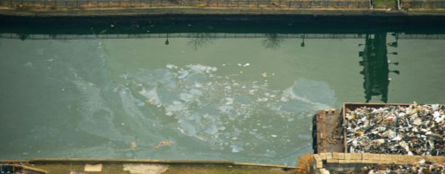
Research findings
The research realized that environmental economics is so important. Looking at the economic activities taking place on NYC Gowanus canal, it is evident that people use natural resources to make a living through agricultural activities, and fishing. Therefore, it means without the environment or nature, there would be little going on in terms of economic activities around the canal (Alexiou, 2015).
The researcher came up with various environmental economics concerns which are the subject of discussion in the study. The following research findings were realized;
- It is important to make policies that promote a clean environment in the Gowanus Canal. However, this can be achieved through government intervention in the economy in order to reduce pollution and so on.
- The environmental objectives involve a number of key areas such as environmental quality, sustainable development, and biodiversity (Hirsch, & Teicher, 2016).
Environmental and economic importance of the topic.
Environmental economics is concerned with the efficient use of resources in order to give a direct value and the raw material which are needed for economic purposes. Therefore, the economy in Gowanus Canal depends on the environment. From an economic view of the environment, both principles need each other in order to co-exist. Economists believe that in order for the environment to be economically productive, there is a need for government intervention, reduction of environmental externalities and respond to problems on the efficient use as well as the allocation of natural resources (O'Neill, & Van, 2016).
The topic takes the researcher as well as the audience in a journey towards a safer and cleaner environment. It is fair to say that, we can’t do away with economic activities in order to keep a clean environment. However, the question behind this topic is that what can be done in regard to environmental economics to protect the environment (Smith, & Oxford University Press, 2011).
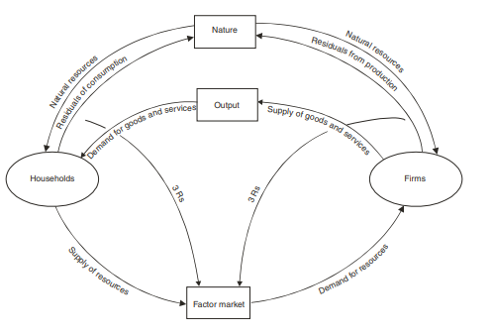
Source: (O'Neill, & Van, 2016).
From the above figure, it is clear that the environment in the Gowanus Canal (which provides natural resources) is the central factor that economic activities exist. It is the main source of resources which are necessary for carrying out economic activities such as energy production, and the mining industry among other key areas. The environment is the main supplier of both renewable and non-renewable resources. Household firms are directly connected to the environment and depend on natural resources in production (O'Neill, & Van, 2016).
Effects on the environment and economy
The environment takes care of and the same should reciprocate on the other hand. There are a number of typical Environmental Economics issues that affect the system. For example depletion of resources in Gowanus Canal and so forth, it is important for the human community to come up with policies which regulate how economic activities make use of the environment in order to protect it. When untreated waste from the companies surrounding the Gowanus Canal is released into the river, it affects the environment. Environmental economics teaches us that we should make regulations which protect the land, the habitats, and resources available. For example, fossil fuels, aquatic creatures, and the atmosphere among other key areas. Environmental economics provides natural science understanding and complex ecological systems knowledge which surrounds economic activity impacts and causes (Alexiou, 2015).
How improvements/solutions will affect the future environment & economy
Sustainable development does not only involve sustainability but also the maintenance of the environment. Sustainable development involves different ways which improve the standards of living and enhance the development of the environment. Environmental economics also focuses on development in research towards a sustainable environment. Integration of economic development and the environment is essential in the improvement of environmental quality (Goodstein, 2019).
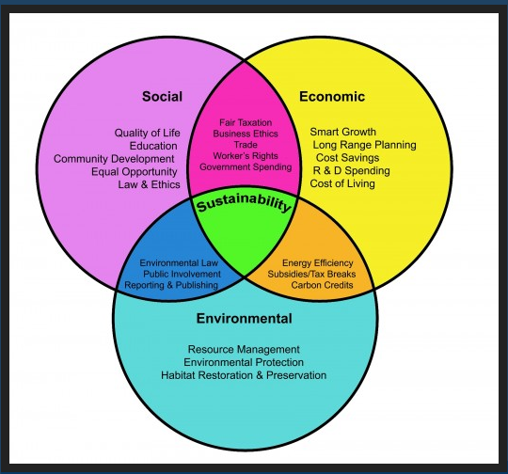
From the above figure, it is evident that sustainable environment not only creates a sustainable economic environment but also the social environment. Economic sustainability involves the creation of an ecosystem which takes care of resource depletion, extinction of natural resources, deforestation, and pollution (Hirsch, & Teicher, 2016). A number of key question must be answered in the promising approach to promote environmental outcomes in the Gowanus Canal;
- What are the main effects of economic development on the environment?
- What is being done to safeguard biodiversity as well as adaptation of changing climatic conditions?
- What financial models can be implemented to enhance sustainable use of resources?
- How can technology be used to control pollution, as well as population growth which affects the environment? (Hirsch, & Teicher, 2016).
Improvements on the Gowanus Canal will mean that the economic activities which have been affecting the river must be taken care of. Policies must be formulated which will control pollution of the canal. Improvements of the river will reduce pollution through a number of enforcement measures such as treatment of the waste before it is released into the river. Environmental sustainability in the surrounding must also be implemented through activities such as afforestation. These improvements will protect the environment and prevent the deaths of aquatic life in the future. Taking environmental concerns seriously will affect the future positively and take care of the environment and its resources.
The main effects of economic development on the environment are the destruction of nature. The natural environment in the Gowanus Canal has been greatly affected by pollution caused by factories across the area. The factories release to the environment (rivers and water basins) thus the water is polluted. The aquatic life die and the water cannot be used for human consumption. In order to safeguard biodiversity, the local authority has come up with policies which seek to control pollution in order to safeguard biodiversity. Cleaning up of the canal has been implemented to save the water sources. Financial models which can be implemented include taking a bigger share of the amount earned through the economic activities to safeguard biodiversity and promote the environment e.g. through cleaning of the natural environment etc. Technology is important in the promotion and development of the environment. It can be used to efficiently control pollution such as treating waste before it is released in the Gowanus Canal.
Conclusion
Environment and economics go hand in hand. It entails all the economic activities which are done on the environment which is the main source of the economic resources. It is mandatory to acknowledge the value of the environment in economic growth as well as the goods or materials provided by the Earth’s environmental systems. Environmental economics plays an important role when the world is facing environmental issues in both local and international levels. Environmental economics spells out a number of key issues which surround the misuse of the natural environment as well as the decision making in environmental policing across the world. The challenge of meeting sustainable development is pressing. Environmental economics can be used to reduce poverty as well as address the social and economic aspects as well as environmental dimensions.

Bibliography
Alexiou, J. (2015). Gowanus: Brooklyn's Curious Canal. New York: NYU Press.
Hirsch, S., & Teicher, J. G. (2016). Gowanus waters.
In Dasgupta, P., In Pattanayak, S., & In Smith, V. K. (2018). Handbook of environmental economics: Volume 4.

Goodstein, E. S. (2019). Economics and the environment. New York: John Wiley & Sons.

O'Neill, K. M., & Van, A. D. J. (2016). Taking chances: The coast after Hurricane Sandy. Environmental economics: A very short introduction. Oxford: Oxford University Press.
Singh, K., & Shishodia, A. (2017). Environmental economics: Theory and applications. Los Angeles: SAGE Publications.

